How can Coco-Cola grow value added dairy in Africa by the acquisition of Chi Ltd.?

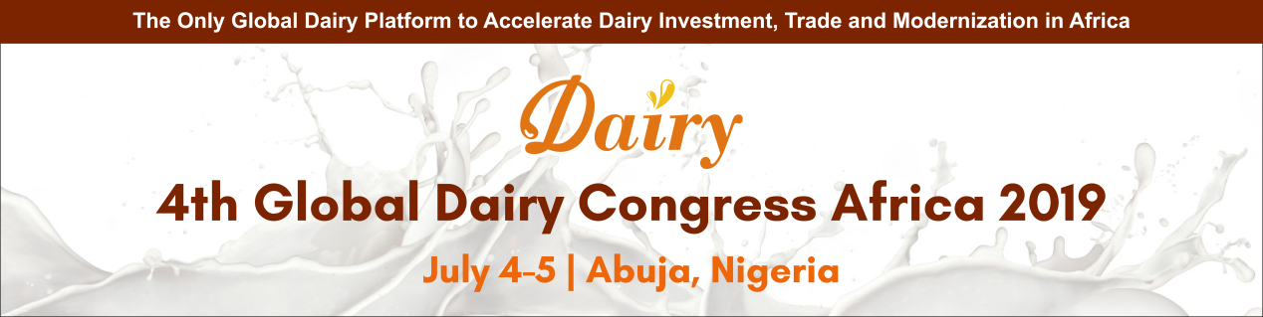
The 4th Global Dairy Congress Africa 2019 is launching on Abuja, Nigeria on July 4-5th. You will join in the only global platform to accelerate dairy investment, trade and modernization in Africa.
Registration Access

At the beginning of this year, Global beverage company Coca-Cola Company has completed its acquisition of Chi Ltd. in Nigeria. This acquisition further signals Coca-Cola’s optimism about Africa’s consumer opportunity and a commitment to its long-term investment and growth plan on the continent, where it has been present for more than 90 years.

Chi’s diverse range of beverages perfectly complements Coca-Cola’s existing portfolio, enabling them to accelerate expansion into new categories and grow our business in Africa. And also, Coca-Cola will support the Chi management team in building on the company’s remarkable heritage and achievements, while using the scale of the Coca-Cola system to replicate their success in more markets across Africa.

4th Global Dairy Congress Africa 2019 (Abuja, Nigeria, July 4-5th) confirmed the participation of Mr. Probal Bhattacharya, the Marketing Director from Chi Ltd. Mr. Probal Bhattacharya will share how they grow value added dairy products in Nigeria. Join us to learn more cases from 80+ global and local dairy processors!
>>> Book your seats now

Global Series Dairy Congress Upcoming:
5th Global Dairy Congress Asia 2019 (May 16-17, Jakarta, Indonesia)
4th Global Dairy Congress Africa 2019 (July 4-5, Abuja, Nigeria)
2nd Global Dairy Congress Russia 2019 (Oct. 15-16, Moscow, Russia)
2nd Global Dairy Innovation Congress MENA 2020 (Jan. 20-21, Dubai, UAE)

Best Regards,

Rala| Organizing Committee of Global Series Dairy Congress | SZ&W Group
Email: ralaw@szwgroup.com | Tel: +86 21 5830 0710-8099 | Mob: +86 132 6222 2731

